**CAR SALES SYSTEM IN ADVANCED JAVA**

**B.Tech .SEMINAR REPORT**

Submitted to Dr. Babasaheb Ambedkar Technological University in Lonere in Partial Fulfillment of the

Requirements for the Degree of BACHELOR OF TECHNOLOGY in

Computer Engineering.

By

|  |
| --- |
| **Puja Vilas Bonde** |
| **Harshvardhan Sham Bhavsar** |
| **Kirti Nitin Mahajan** |

Guide: Mr.D.R.Nemade

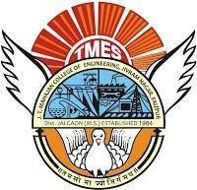

**DEPARTMENT OFCOMPUTER ENGINEERING**

**J.T. MAHAJAN COLLEGE OF ENGINEERING, FAIZPUR**

**JUNE 2023**

# PREFACE

We have made this report file on the topic**Car Sales System In Advanced Java,** We have tried my best to elucidate all the relevant detail to the topic to be included in the report. While in the beginning we have tried to give a general view about this topic.

Our efforts and wholehearted co-corporation of each and everyone has ended on a successful note. We express my sincere gratitude to who assisting us throughout the preparation of this topic. We thank him for providing us the reinforcement, confidence and most importantly the track for the topic whenever we needed it.

## Index

## Content Page No.

1. Introduction ……………………………………………………1

## Needs …………………………………………………………..2

1. Objective ………………………………………………………3
2. Scope of project ……………………………………………….4
3. Technology proposed for project ……………………………...5
4. Feasibility Study……………………………………………….6
5. Case Tools……………………………………………………..7
6. Data Flow Diagram……………………………………………8
7. Testing tools…………………………………………………..10

9.1 Black Box Testing………………………………………...12

9.2 White Box Testing………………………………………...13

9.3 GUI Testing……………………………………………….13

1. Onscreen Views.………………………………………………14
2. Limitation……………………………………………………..17
3. Conclusion …………………………………………………...18
4. References……………………………………………………19

**J.T. MAHAJAN COLLEGE OF ENGINEERING, FAIZPUR**

**Department of Computer Engineering**

**CERTIFICATE**



This is to certify that the project entitled, **“ Car Sales System In Advanced Java ”**, which is being submitted herewith for the award of B.E. is the result of the work completed by **Puja Vilas Bonde, Harshvardhan Sham Bhavsar, Kirti Nitin Mahajan.** under my supervision and guidance within the four walls of the institute and the same has not been submitted elsewhere for the award of any degree.

Prof. D. R. Nemade Dr.K.S.Bhagat

Guide Department of Computer Engg.

Examiner Dr.R.D.Patil

Principal

J.T.M.C.O.E,Faizpur

**DECLARATION**

We hereby declare that the project entitled, **“Car Sales System In Advanced Java”** was carried out and written by me/us under the guidance of Prof. D. R. Nemade Department of Computer Engineering. This work has not been previously formed the basis for the award of any degree nor has been submitted elsewhere for the award of any degree.

Place: Faizpur

Date:

**ACKNOLEDGEMENT**

We would like to express my special thanks of gratitude to our assistant professor guide **Prof. D. R. Nemade** and our principal ( Dr.R.D.Patil ) who gave us the golden opportunity to do this project on the topic **Car Sales System In Advanced Java**. It helped us in doing a lot of Research and we came to know about a lot of things related to this topic.

Finally, we would also like to thank my parents and friends who helped me a lot in finalizing this project within the limited time frame.

|  |
| --- |
| **Puja Vilas Bonde** |
| **Harshvardhan Sham Bhavsar** |
| **Kirti Nitin Mahajan** |

## Abstract of Car Sales System In Advanced Java

If you run a business, you have a choice when it comes to handling sales. You can choose a traditional cash register, which keeps track of the money your business has taken in each day, or a point-of-sale system that provides a number of additional features as well.

In the existing System it is difficult to maintain the car information individually and to supply for the customers who are eager to buy them. Customer has to face difficulty in order to know the information of car like manufacturing year, car model and other valuable information in a single domain. Our main idea is to develop a system where we can have all the required information for the user in order to effectively interest him in the process of buying a car. In the Proposed System, application can maintain car details like manufacturer, year of manufacturing, price and model etc. We can also view all the car details which are kept for sale effectively and we can search for our desired car. With this Customer can get the information quickly like car details which have been entered clearly. This application mainly consists of 5 modules: user module, admin module, dealer module, viewing all cars module, adding cars module.

## List of Figure

|  |  |  |
| --- | --- | --- |
| Sr No. | Figure Name | Page No. |
| 1. | Data Flow Diagram | 9 |
| 2. | Activity Diagram | 10 - 11 |
| 3. | Onscreen Views / Output | 14 - 16 |

## Introduction

The Car Sales System project is an advanced Java-based application that aims to streamline and automate the process of buying and selling cars. This project provides a comprehensive solution for car dealerships and buyers by leveraging the power of Java programming and advanced software development techniques.

In the current era, the automotive industry is rapidly evolving, and car dealerships face the challenge of efficiently managing their inventory, tracking sales, and providing a seamless experience for customers. The Car Sales System project addresses these challenges by offering a user-friendly interface and robust functionalities that enhance the overall car buying and selling process.

This system enables car dealerships to manage their inventory effectively, including storing and updating information about available cars, their specifications, pricing, and any additional features. It provides a centralized platform for sales representatives to access up-to-date data, enabling them to assist customers efficiently and make informed sales decisions.

For potential car buyers, the Car Sales System project offers an intuitive and interactive interface, allowing them to search and browse through the available inventory, filter cars based on their preferences, and compare different models. The system also facilitates the scheduling of test drives, online reservations, and secure payment processing, ensuring a seamless purchasing experience.

Advanced Java technologies are utilized in the development of this system to ensure reliability, scalability, and security. The project incorporates concepts such as object-oriented programming, database management, GUI development, and data encryption to provide a robust and efficient solution.

Overall, the Car Sales System project in Advanced Java empowers car dealerships to streamline their operations, optimize customer satisfaction, and increase sales revenue. It revolutionizes the traditional car buying and selling process, transforming it into a modern, efficient, and user-friendly experience for both dealerships and buyers.

**1**

**NEED**

* Efficient Inventory Management
* Streamlined Sales Process
* Enhanced Customer Experience
* Increased Sales Revenue
* Data Accuracy and Consistency
* Real-time Reporting and Analytics
* Improved Communication and Collaboration
* Secure Transactions
* Scalability and Customization
* Competitive Advantage

**2**

**OBJECTIVES**

**Objectives of project:**

* **Efficient Inventory Management:** The objective is to develop a car sales system that enables effective management of inventory by providing accurate and up-to-date information about available cars, their specifications, pricing, and features.
* **Streamlined Sales Process:** The objective is to create a system that simplifies the sales process by providing a centralized platform for sales representatives to access real-time information, enabling them to assist customers efficiently and make informed sales decisions.
* **Enhanced Customer Experience:** The objective is to deliver a user-friendly interface that allows potential buyers to easily search, browse, and compare cars, schedule test drives, make online reservations, and securely process payments, ensuring a seamless and satisfying customer experience.
* **Improved Reporting and Analytics:** The objective is to provide comprehensive reporting and analytics capabilities to generate insights on sales performance, inventory turnover, customer preferences, and market trends. This data-driven approach supports informed decision-making and future sales strategies.
* **Secure Transactions and Data Protection:** The objective is to implement robust security measures, including data encryption and secure payment processing, to protect customer information and ensure secure transactions, thereby establishing trust and confidence among buyers.

\

**3**

**SCOPE OF PROJECT**

The scope of the **Car Sales System** is as follows:

1. Development of a comprehensive system that automates the car buying and selling process.
2. Creation of a user-friendly interface for both car dealerships and potential buyers.
3. Implementation of efficient inventory management, including storing and updating car information.
4. Integration of advanced search and filtering functionalities to assist buyers in finding their desired cars.
5. Incorporation of secure payment processing mechanisms for online reservations and purchases.
6. Provision of real-time data access to sales representatives for efficient customer assistance.
7. Generation of comprehensive reports and analytics for sales performance and inventory tracking.
8. Customization options to accommodate specific dealership requirements and integrate with other systems.
9. Implementation of robust security measures to protect customer data and ensure secure transactions.
10. Scalability to accommodate future enhancements and adapt to changing market demands.

**4**

**TECHNOLOGY PROPOSED FOR PROJECT**

**HARDWARE AND SOFTWARE REQUIREMENT**

The most common set of requirements defined by any operating system or software application is the physical computer resources, also known as hardware. A hardware requirements list is often accompanied by a hardware compatibility list (HCL), especially in case of operating systems. An HCL lists tested, compatibility and sometimes incompatible hardware devices for a particular operating system or application. The following sub-sections discuss the various aspects of hardware requirements.

**HARDWARE REQUIREMENTS FOR PRESENT PROJECT**:

PROCESSOR : Intel dual Core ,i3

RAM : 1 GB

HARD DISK : 80 GB

**SOFTWARE REQUIREMENTS:**

Software Requirements deal with defining software resource requirements and pre-requisites that need to be installed on a computer to provide optimal functioning of an application. These requirements or pre-requisites are generally not included in the software installation package and need to be installed separately before the software is installed.

**SOFTWARE REQUIREMENTS FOR PRESENT PROJECT:**

OPERATING SYSTEM : Windows 7/ XP/8

FRONT END : Java

SERVER SIDE SCRIPT : -

DATABASE : Mysql

**5**

**FEASIBILITY STUDY**

At the time of the development, we have gone through the following phases:

**Recognition of need (Requirement specification):**

         It refers to the organization’s needs, requirements and expectations from the project to be developed. After recognizing the organization’s need, it has been taken in writing and then a rough idea of the system/project has been given to the firm.

1. **Feasibility Study:**

 It is always essential to evaluate the various aspects before we develop the project. Evaluation should always justify the cost and benefits ratio. Economic, social and technical feasibility of project is analyzed.

1. **Data Collection:**

Here comes an important aspect of project development i.e. data collection. For this to accomplish, we observe registers, bills, invoices and order orders

1. **Data Normalization:**

Normalization means allowing only a single value in a table’s row and column intersection. For this, entities are identified from the data collected and normalized tables with appropriate relationship and minimized redundancy are designed.

1. **System Design:**

This step includes drawing of different diagrams such as DFD and ERD. It includes database design, form design etc.

1. **Coding:**

It is the most critical stage among all the stages of development.  It has taken approximately seven days to complete. It involves giving functioning to data entry forms with the help of action, validation, calculations and linking of different data entry forms.

1. **Testing:**

It involves testing of the working of the project.

1. **Implementation:**

This involves deployment of project to client side.

1. **User training:**

It is one day activity involving training to the user to operate the project.

**6**

**CASE TOOLS**

It is always essential to evaluate the various aspects before we develop a system. Evaluation should always justify the cost and benefits ratio. If it is found that benefits are less as compare to the cost of project, then it is better to avoid going in for computerization.

The key consideration involved in the Feasibility analysis is:

**1. Technical Feasibility.**

**2. Economical Feasibility.**

**3. Social Feasibility.**

**1. Technical Feasibility:**

This study is carried out to check the technical feasibility, that is, the technical requirements of the system. Any system developed must not have a high demand on the available technical resources. This will lead to high demands being placed on the client. The developed system must have a modest requirement, as only minimal or null changes for the implementing this system.

1. **Economical feasibility**:

This study is carried out to check the economic impact will have on the system will have on the organization. The amount of fund that the company can pour into the research and development of the system is limited. The expenditures must be justified. Thus, the developed system as well within the budget and this was achieved because most of the technologies used are freely available. Only the customized products have to be purchased.

1. **Social Feasibility:**

The aspect of study is to check the level of acceptance of the system by the user. This includes the process of training the user to use the system efficiently. The user must not feel threatened by the system, instead must accept it as a necessity. The level of acceptance by the users solely depends on the methods that are employed to educate the user about the system and to make him familiar with it. His level of confidence must be raised so that he is also able to make some constructive criticism, which is welcomed, as he is the final user of the system.

**7**

**Data Flow Diagram (DFD)**

* Data flow diagram is graphical tool which is used to describe and analyze the movement of data through a system. They focus on the data flowing into the system, between processes and in & out of data stores.
* DFD is a graphical technique that detects information flow and transformation that are applied as data move from input and output.
* DFD is a central tool and the basis from which other components are developed.
* DFD provides mechanism for a final modeling as well as information flow modeling.
* DFD has very simple notation which are easily understood by the users & those who involved in the system.

**Symbol used for DFD**

**Symbol Meaning**

External Entity as source

Destination.

Process or Function.

Indicates direction of data flow

File Storage i.e. data is

Stored for use by one or more.

Stored for use by one or more.

**8**

**Data Flow Diagram**

+-------------------+

| Car Sales System |

+---------+---------+

|

+----------v----------+

| User Interface |

+----------+----------+

|

+----------v----------+

| Business Logic |

+----------+----------+

|

+----------v----------+

| Database |

+----------+----------+

|

+----------v----------+

| External Services |

+---------------------+

**9**

**Activity Diagram**

+-------------------+

| Car Sales System |

+---------+---------+

|

+---------v---------+

| Start Process |

+---------+---------+

|

+---------v---------+

| Browse Cars |

+---------+---------+

|

+---------v---------+

| Select Car |

+---------+---------+

|

+---------v---------+

| Provide Details |

+---------+---------+

|

+---------v---------+

| Check Stock |

+---------+---------+

|

+-----------v----------+

| Check Availability |

+-----------+----------+

|

+-----------v----------+

| Calculate Price |

+-----------+----------+

**10**

|

+---------v---------+

| Finalize Order |

+---------+---------+

|

+-----------v----------+

| Process Payment |

+-----------+----------+

|

+---------v---------+

| Generate Invoice |

+---------+---------+

|

+---------v---------+

| Complete Process |

+---------+---------+

|

**11**

**TESTING TOOLS**

Testing is important from the point of view of accurate functioning of the project. There are many testing measures and tools available to test a project.

Basic tools used to test this project are:

1. Black Box Testing.
2. White Box Testing
3. GUI Testing

**1. Black Box Testing:**

It is a method of software testing that tests the functionality of an application as opposed to its internal structures or workings. Specific knowledge of the application’s code/internal structure and programming language in general is not required. The tester is only aware of what the software is supposed to do, but not how i.e. when he enters a certain input, he gets certain output; without being aware of how the output was produced. Tests cases are build around specifications and requirements, i.e., what the application is supposed to do. It uses external descriptions of the software, including specifications, requirements and designs to derive test cases. These test designer select valid and invalid inputs and determine the correct output. There is knowledge of the test object’s internal structure.

                This method of test can be applied to all levels of software testing: Unit, Integration, System and Acceptance. It typically comprises most if not all testing at higher levels, but can also dominate unit testing as well.

**The advantages of this type of testing include:**

* The test is unbiased because the designer and the tester are independent of each other.
* The tester does not need knowledge of any specific programming languages.
* The test is done from the point of view of the user, not designer.

**The disadvantages of this type of testing include:**

* The case can be redundant if the software designer has already run a test case.
* The test cases are difficult to design.

**12**

**2. White Box Testing:**

White box testing is a method of testing software that tests internal structures or workings of an application, as opposed to its functionality. In white-box testing an internal perspective of the system, as well as programming skills, are required and used to design the test cases. The tester chooses input to exercise paths through the code and determine the appropriate outputs. While white-box testing can be applied at the unit, integration and system levels of the software testing process, it is usually done at unit level. It can test paths within a unit, paths between units during integration, and between subsystems during a system level test. Though this method of test design can uncover many errors or problems, it might not detect unimplemented parts of the specification or missing requirements.

**White-Box test design techniques include:**

* Control flow Testing
* Data flow Testing
* Branch Testing
* Path Testing

For a complete software examination, both white box and black box tests are required.

**3. Graphical User Interface Testing:**

It is the process of testing a product’s graphical user interface to ensure it meets its written specifications. This is normally done through the use of a variety of test cases. It checks only the user friendliness. The creation of the user interface is less time consuming for the user but more complex for the programmer. It must be tested for its sole purpose.

**This test must be carried out to ensure:**

* Windows open properly.
* All data contents are properly addressable.
* All the graphical elements are available and displayed.

Multiple or incorrect mouse click do not produce side effects

**13**

**Onscreen Views**

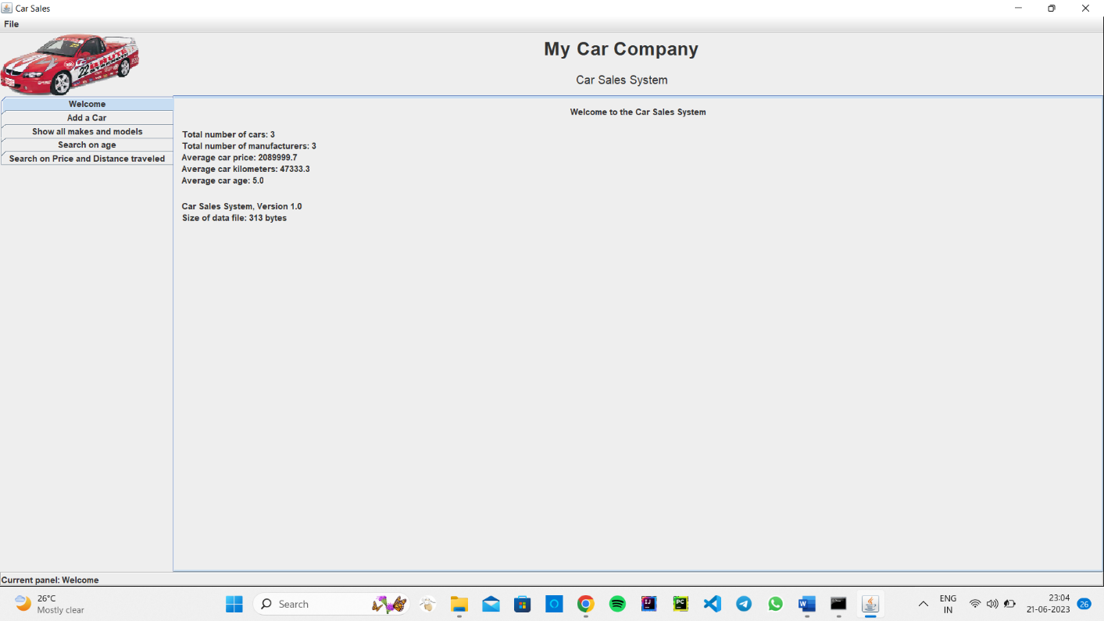

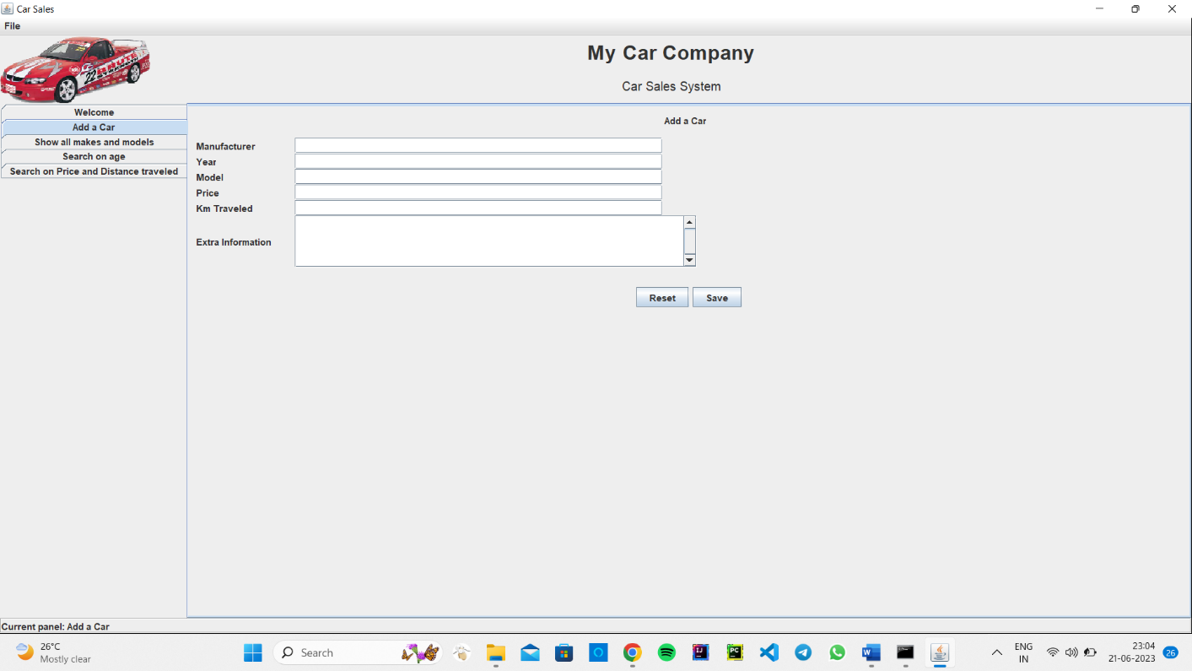

**14**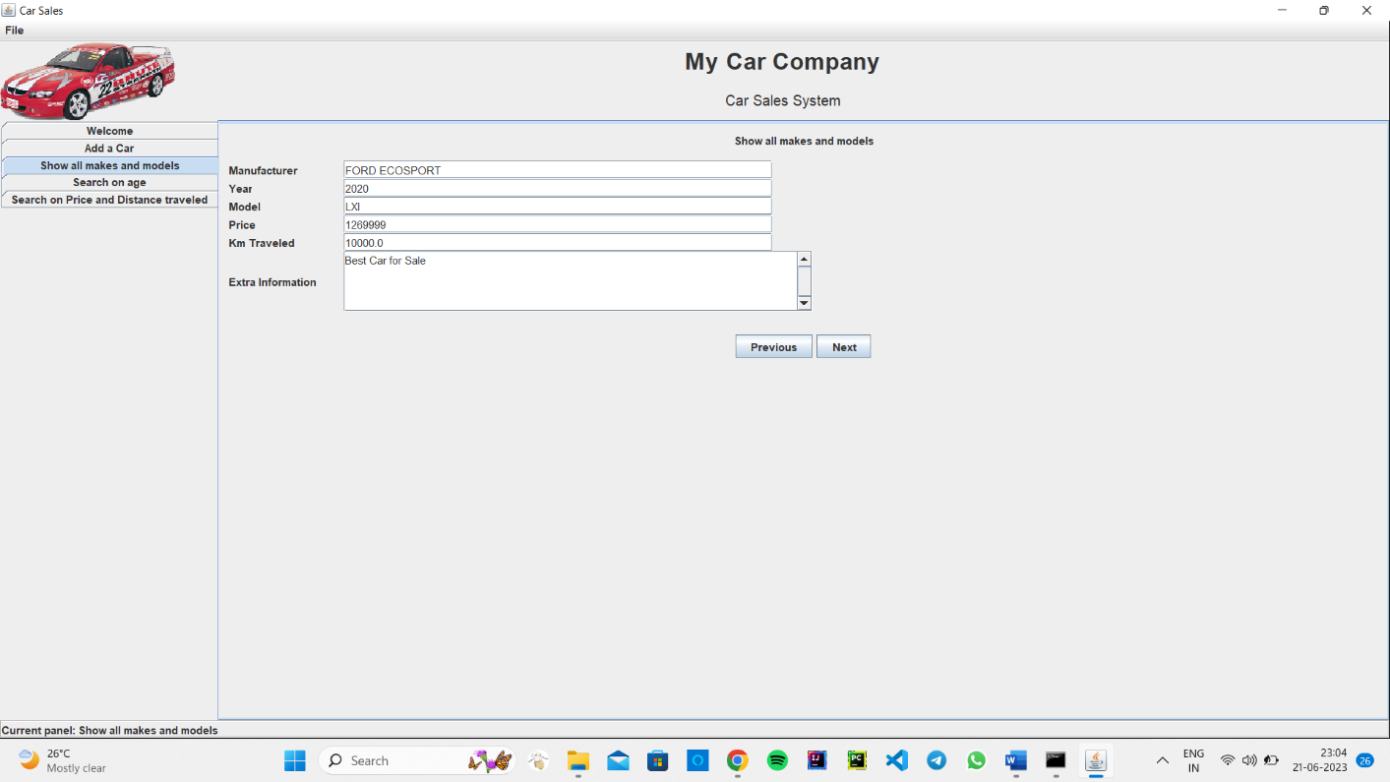

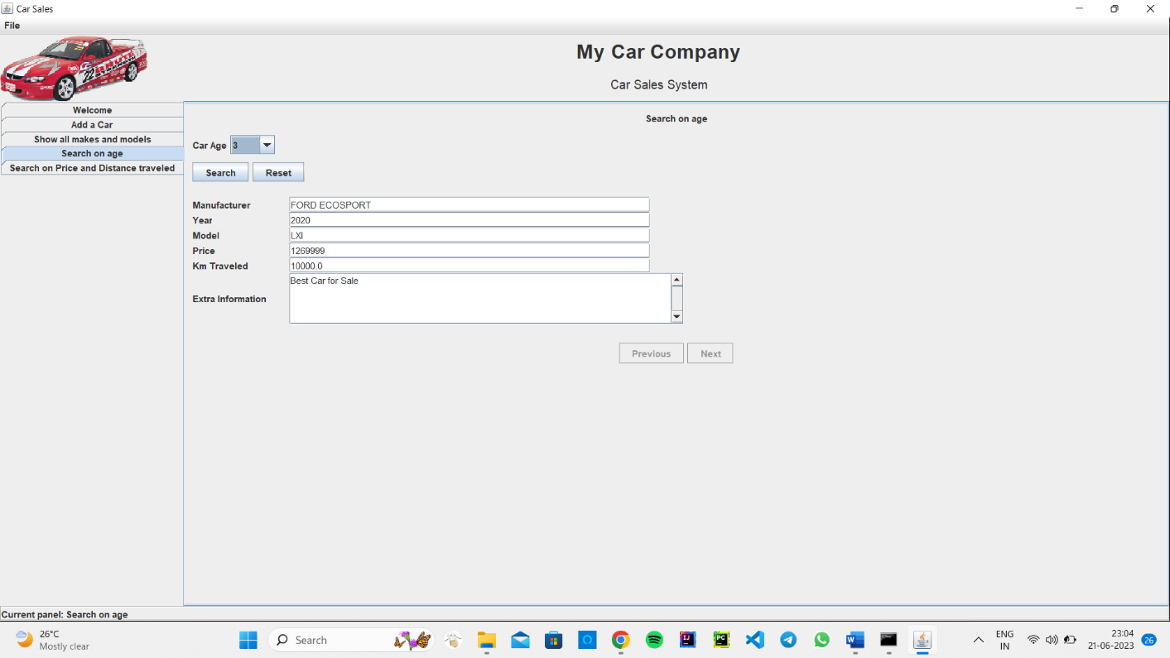

**15**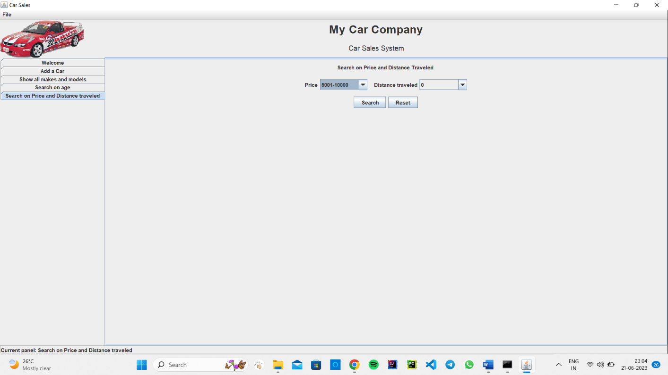

**16**

**LIMITATION**

* Lack of physical inspection: One limitation of a car sales system project is the inability for customers to physically inspect and test drive the cars before making a purchase, which can impact their decision-making process.
* Limited personal interaction: The system may lack the personal interaction and guidance provided by sales personnel, which can affect the customer experience and may result in potential misunderstandings or miscommunication.
* Dependency on accurate inventory data: The effectiveness of the system heavily relies on accurate and up-to-date inventory data. Any discrepancies or delays in updating the inventory can lead to customer dissatisfaction and potential errors in the sales process.
* Security and privacy concerns: The car sales system involves the collection and storage of customer personal and financial information. Ensuring robust security measures to protect sensitive data and addressing privacy concerns is crucial but can be challenging.
* Technical glitches and downtime: Like any software system, the car sales system may encounter technical glitches, software bugs, or server downtime, which can disrupt the sales process and negatively impact customer satisfaction. Regular maintenance and quick issue resolution are necessary to minimize such limitations.

**17**

**CONCLUSION**

* Efficient and streamlined process: The car sales system implemented in Java provides an efficient and streamlined process for customers to browse cars, select a car, provide details, and complete their purchase with ease.
* Improved customer experience: By leveraging technology, the system enhances the customer experience by providing a user-friendly interface, accurate inventory information, and automated processes such as price calculation and invoice generation.
* Enhanced inventory management: The car sales system effectively manages the inventory by tracking stock availability, updating quantities in real-time, and providing insights to management for informed decision-making regarding stock replenishment and sales strategies.
* Integration with external services: The system seamlessly integrates with external services such as payment gateways, enabling secure and convenient payment processing for customers, further enhancing the user experience.
* Data accuracy and security: With a robust database structure and appropriate security measures, the car sales system ensures data accuracy and protects sensitive customer information, building trust and confidence among customers.

In conclusion, the car sales system in Java optimizes the car sales process, improves customer satisfaction, enhances inventory management, integrates with external services, and prioritizes data accuracy and security, contributing to a more efficient and successful car sales operation.

**18**

**REFERENCES**

**Books:**

1.Java Programming

2. Advanced Java Programming

**Websites:**

1. [www.tutorialspoint.com](http://www.tutorialspoint.com/)
2. [www.w3schools.com](http://www.w3schools.com/)
3. [www.codewithharry.com](http://www.codewithharry.com)
4. [www.javatpoint.com](http://www.javatpoint.com)

**19**